**Artifact 1**

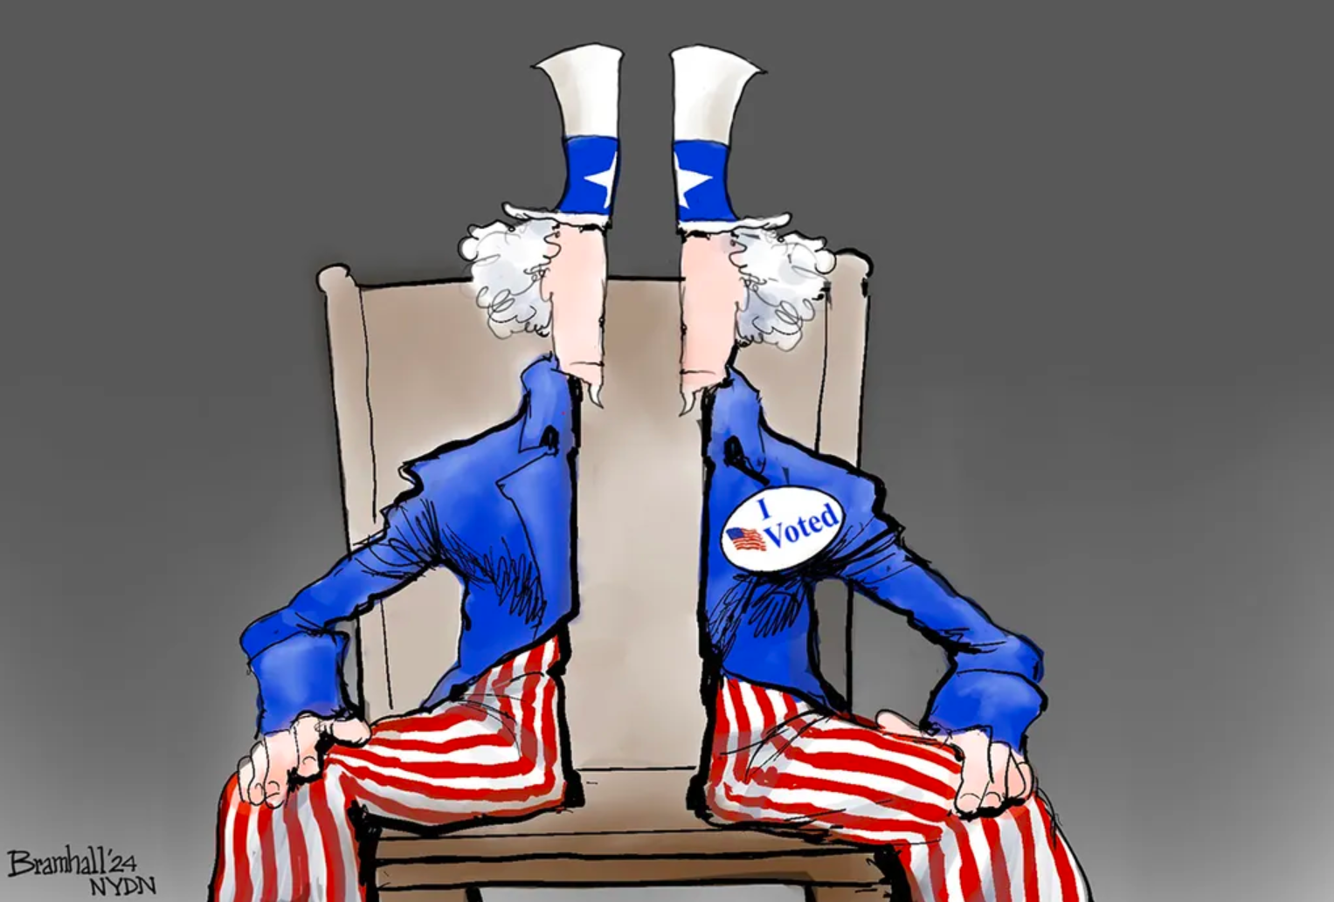

**Artifact 2**

# **a song in the front yard**

By [Gwendolyn Brooks](https://www.poetryfoundation.org/poets/gwendolyn-brooks)

I’ve stayed in the front yard all my life.

I want a peek at the back

Where it’s rough and untended and hungry weed grows.

A girl gets sick of a rose.

I want to go in the back yard now

And maybe down the alley,

To where the charity children play.

I want a good time today.

They do some wonderful things.

They have some wonderful fun.

My mother sneers, but I say it’s fine

How they don’t have to go in at quarter to nine.

My mother, she tells me that Johnnie Mae

Will grow up to be a bad woman.

That George’ll be taken to Jail soon or late

(On account of last winter he sold our back gate).

iv. a song in the back yard

I’ve wallowed in the back yard all my life.

I want to slide ’round front

Where it’s gold-splashed and guarded and spined fragrance grows.

A girl gets a craving for rose.

I want to go in the front yard now

and far away from these nappy weeds — this alley

too. I wanna see where the well-off children play.

I want some proper fun today.

They do some miracle things.

They have that secret kinda fun.

My daddy says *They’re uppity*, but I think it’s fine

how they’re tucked in their beds by a quarter to nine.

My mama, with her country ways, try as she may,

will never turn me into a weeds and wildflowers woman,

that’s a fact. I only stay up late

on account of all her party folk flooding our back gate.

But that’s OK. I think front yard folk are perfect. Really, I do.

And I’m gonna be a righteous woman, too.

And wear a soft cardigan, cashmere trimmed in lace.

And stroll ’round all of Lawndale with this righteous on my face.

**Artifact 3**

<https://apnews.com/article/fema-misinformation-helene-milton-hurricane-aid-recovery-468b036784b1db05937e9a34d0146041>

# **As FEMA prepares for Hurricane Milton, it battles rumors surrounding Helene recovery**

By Rebecca Santana

WASHINGTON (AP) — The rumors surrounding Hurricane Helene are many. [There are false claims](https://apnews.com/article/hurricane-helene-trump-musk-conspiracy-theories-misinformation-fe81869765d778ac2ff3dc5f9ac18e10) that people taking federal relief money could see their land seized. Or that $750 is the most they will ever get to rebuild. Or that the agency’s director — on the ground since the storm hit — was beaten up and hospitalized.

As the U.S. agency tasked with responding to disasters, the [Federal Emergency Management Agency](https://apnews.com/article/hurricane-helene-fema-trump-disasters-b191d88e2ab77d3b79eeeb860e4ae13b) has been fighting misinformation since Helene slammed into Florida nearly two weeks ago and brought a wide swath of destruction as it headed north. The false claims are being [fueled](https://apnews.com/article/trump-harris-hurricane-helene-misinformation-552e413dfb6c1b3e37eca0d2114668ea) by former President Donald Trump and others just ahead of the presidential election, and are coming as the agency is gearing up to respond to a second major disaster: [Hurricane Milton](https://apnews.com/article/hurricane-milton-florida-tampa-7678939c52fdf00da748937d22df1fac) is set to strike Florida on Wednesday.

[FEMA Administrator Deanne Criswell](https://apnews.com/article/hurricane-helene-fema-826effecab238ff0acf0556ad64b0df2) told reporters Tuesday that she has never seen the disinformation problem as bad as it’s been with Helene, which hit hard in North Carolina, a state key to winning the election.

“It’s absolutely the worst that I have ever seen,” an uninjured Criswell said.

She said the online rumors are demoralizing for staff or volunteers who have left family behind to deploy to a disaster zone. And she said there’s a real risk that local residents will hear these rumors and be too afraid to apply for the help they’re entitled to.

Drew Reisinger, a Democratic registrar of deeds in Buncombe County, North Carolina, said part of the problem is that [the affected regions](https://apnews.com/article/hurricane-helene-death-toll-asheville-north-carolina-34d1226bb31f79dfb2ff6827e40587fc) have been largely [without means of communication](https://apnews.com/article/hurricane-helene-asheville-north-carolina-1a2255b9d1dd5cd9554a76b45c7a695c), so outside voices have an easier time setting the narrative.

“It’s almost easier to let misinformation happen when all of our phone lines and internet lines have been down for so many days that we can’t refute it,” he said.

For days after Helene hit, his office did wellness checks when relatives or friends reached out to say that they hadn’t been able to get in touch with people in the area. The vast majority of people were OK. But at one point, his office said it had done 15,000 wellness checks and that was mistakenly interpreted as meaning 15,000 people were missing.

He pushed back on suggestions that relief supplies weren’t getting to people.

“Even in my office and the registered deeds office, we are taking so much stuff out into every holler, and we’re finding that there’s already so much food and water at every local Baptist church ... at the Elks Club and at the homeless shelter,” he said.

U.S. Rep. Chuck Edwards, a North Carolina Republican, put out a statement Tuesday debunking “outrageous rumors” that FEMA is halting trucks from bringing in supplies, abandoning rescue efforts to bulldoze [the mountain town of Chimney Rock](https://apnews.com/article/hurricane-helene-chimney-rock-north-carolina-da802219b70161816b73b24482b50684), is running out of money and more. FEMA also has [set up a website](https://www.fema.gov/disaster/current/hurricane-helene/rumor-response) debunking conspiracy theories.

But others questioned where FEMA and other help has been. Pete Loftin and Crystal Pierce Clontz were talking Monday outside a donation center set up in Sunny View, North Carolina. They compared notes about how many bars they had been able to get on their cellphones — not many. Loftin had spent two days trying to cut his way out of his damaged driveway but wasn’t sure how he could even apply for FEMA help.

“We all come together and are fending for ourselves,” he said.

FEMA said Tuesday that [federal assistance for survivors of Helene](https://apnews.com/article/hurricane-helene-flooding-insurance-water-damage-fema-disaster-recovery-07bbf25fba01c2fac5f66dd6ac56e0ee), which has [killed 236 people across six states](https://apnews.com/article/hurricane-helene-florida-georgia-carolina-268ba170519c52c2bc1abcbc0b093e53), has hit $286 million. It’s also sent about half a million tarps, 210 generators, more than 16 million meals and other supplies to the affected regions.

This is not the first time that rumors have run rampant following a disaster, although experts say social media has supercharged the phenomenon. Criswell said they ran into similar problems in 2023 after [a massive wildfire in Maui](https://apnews.com/hub/news).

During Helene, false claims have swirled that residents will only get $750 from FEMA and nothing more. That amount specifically refers to one-time payments that people can receive for immediate needs like buying medicine or baby food. People also can apply for a host of other types of assistance, like money for rent while they’re displaced or money to store their belongings while they repair their homes.

The agency also has been falsely accused of confiscating donations intended for Helene and pivoting those [supplies to Ukraine](https://apnews.com/hub/ukraine). Those are separate pots of money distributed by Congress.

The Institute for Strategic Dialogue has tracked the disinformation and misinformation circulating in Helene’s wake. The London-based think tank that tracks online hate, disinformation and extremism said it found 33 posts on the platform X containing claims already debunked by FEMA or others that had generated 160 million views as of Monday.

After a disaster, there’s usually a period where residents work together to dig out and get supplies to strangers and friends alike, said Jeannette Sutton, an assistant professor at the University of Albany who studies how best to communicate with people during a disaster.

But at some point, there is often a transition where that altruism is replaced by a feeling of competition for resources. She’s concerned about what disinformation could do to push communities into competition even faster.

“You can imagine that if people started to come in from the outside kind of stirring things up, that that could help to kind of push people into that more corrosive environment,” she said.

It’s all coming as [FEMA is preparing for Hurricane Milton](https://apnews.com/article/milton-florida-hurricane-d40b1e47fd78844bf1ed528bab5099f1), which is set to [hit Florida’s Tampa region](https://apnews.com/article/hurricane-milton-tampa-bay-ace324900762a0e3c385830f3cf1479b) Wednesday. Agency officials have said repeatedly that they can respond to multiple disasters at once — a message that Criswell hammered home Tuesday.

“FEMA has done this before. We manage complex incidents. We’ve managed multiple complex incidents,” she said.

Craig Fugate, who was FEMA administrator during the Obama administration and before that was Florida’s director of emergency management, reinforced that message.

He said the agency historically has been designed to be able to respond to two major disasters at any one time as well as a number of medium to small disasters. They have layers of staffing that can be deployed, ranging from reservists who get called up to work a disaster to staff at headquarters who agree when they’re hired to deploy as needed.

The agency can pull staff working on long-term disaster recovery to focus on what’s needed immediately — such as Milton response — and can pull from other parts of the Homeland Security Department if needed, Fugate said.

Criswell said the agency has enough money right now to respond to both Helene and Milton. But she did raise concerns that the agency could run into problems around December or January if it doesn’t get more funding. In that case, they might have to pull back from long-term recovery projects to conserve money for the next big disaster, unless they get more funding from Congress.

Another agency key to disaster recovery is [ringing the alarm](https://apnews.com/article/hurricane-helene-small-business-administration-milton-loans-f087fa405a3e0a9e691fd9c6192be259) that funds are running low. The Small Business Administration gives loans to uninsured or underinsured homeowners and to businesses to help them rebuild. President Joe Biden said in [a letter to Congress](https://www.whitehouse.gov/briefing-room/statements-releases/2024/10/04/letter-to-congress-on-disaster-needs/) that aid could run out “in a matter of weeks” if more federal funding is not approved.

**Artifact 4**

[**https://www.psychologytoday.com/us/blog/living-psyched/202405/six-steps-to-disagreeing-better**](https://www.psychologytoday.com/us/blog/living-psyched/202405/six-steps-to-disagreeing-better)

# Six Steps to Disagreeing Better

## Here's a guide to disagreeing with respect and understanding.

By Ray Christner

Conflict and disagreements surround us every day. We can’t turn on the television or engage in [social media](https://www.psychologytoday.com/us/basics/social-media) without seeing disputes of some sort; these often become toxic and unhealthy, with people attacking each other for their opinions.

For most of us, these disputes can be small and not amount to much. Yet, other times, they can result in tension, conflict, and even disconnection.

Whether with friends, family, coworkers, or even strangers online, the way we manage these disputes is important to not only our relationships but also our well-being. The ability to disagree better isn’t just a skill but a mindset that can improve communication and relationships, creating a more [empathetic](https://www.psychologytoday.com/us/basics/empathy) society.

## Why Disagreements Happen

So, why do we disagree in the first place? The fact is that disagreements are a fundamental part of human interaction. Conflicts arise naturally from differing viewpoints, values, or knowledge bases. However, other factors exacerbate or intensify these arguments.

## Cognitive Processes

Our individual experiences shape our understanding and interpretation of information, forming unique cognitive schemas—mental structures that assist in organizing and interpreting incoming data. As we encounter different situations, we process them using these schemas, which can result in varied conclusions and, therefore, disagreements. Douglas (2015) notes that relational schemas, whether healthy or maladaptive, are significant in understanding closeness and conflict negotiation styles.

## Cognitive Bias

Confirmation [bias](https://www.psychologytoday.com/us/basics/bias) causes us to unconsciously favor information that aligns with our beliefs and dismiss evidence that contradicts them (Peters, 2022). This mechanism affects how we gather, interpret, and recall information, leading to varied viewpoints even with the same facts.

Similarly, [motivated reasoning](https://www.psychologytoday.com/us/basics/motivated-reasoning) involves actively seeking to justify our beliefs while rejecting contradictory evidence. Both of these, as well as other biases, contribute to the development and maintenance of disagreements.

## Emotional Influences

We develop strong emotional attachments to our beliefs, which are closely linked to our sense of [identity](https://www.psychologytoday.com/us/basics/identity) and values. This is particularly evident in the current U.S. political climate, where debates are often emotionally charged, sometimes discounting factual information.

When our beliefs are challenged, it can trigger emotional responses. These reactions may cloud our judgment and rational thinking, resulting in disagreements and a diminished capacity to listen to others genuinely.

## How Do We Disagree Better?

Having an understanding of why disagreement happens is only half the battle. We must also have thoughtful strategies to transform disagreements into opportunities for connection and understanding. Here are my six steps to disagreeing productively:

## 1. Listen Actively.

Active listening requires fully engaging to hear, acknowledge, and retain what the other person communicates. During disagreements, it’s easy to fall into the trap of formulating a rebuttal while the other person is still speaking rather than genuinely listening to their words and intentions. For instance, in a workplace disagreement about the direction of a project, instead of immediately dismissing your coworker’s ideas, ask clarifying questions to understand their perspective thoroughly.

## 2. Seek Common Ground.

In the middle of many disagreements, there’s usually some common ground. Identifying, highlighting, and expanding on shared values or common [goals](https://www.psychologytoday.com/us/basics/motivation) can show mutual respect and open the door for constructive dialogue. For example, if you and a partner are arguing about financial priorities, start by acknowledging a shared goal, such as securing a comfortable future.

## 3. Embrace a Growth Mindset.

At the heart of constructive dispute is the belief that we can grow from our encounters. Dr. Carol Dweck (2007) coined the term “[growth mindset](https://www.psychologytoday.com/us/basics/growth-mindset),” which encourages us to view disagreements not as threats but as opportunities to learn and understand different perspectives. Thus, being curious rather than defensive opens us to new ideas and deepens our connections with others.

For instance, when you and a friend have a heated discussion about [politics](https://www.psychologytoday.com/us/basics/politics), pause and then respond, “This is a complex issue. We might not agree, but I’d be interested in understanding your viewpoint better.” This invites dialogue and shows [openness](https://www.psychologytoday.com/us/basics/openness) to growth, even if you don’t agree.

## 4. Use “I” Statements.

To prevent heated discussions from becoming personal, focus on facts and express your feelings using “I” statements. This avoids assigning blame and reduces defensiveness. Communicate clearly and calmly, taking responsibility for your own emotions and avoiding generalizations or accusations.

For example, if you’re a parent at a school board meeting disagreeing with a new policy, instead of accusing, “You don’t care about our school and students,” you could say, “As a parent, I feel concerned about the impact of this policy on the safety of our students and staff.”

## 5. Rethink Cognitive Distortion.

We all have cognitive biases, including confirmation bias and motivated reasoning, among others. Be aware of your thoughts and look at ways to rethink the situation.

Maybe at a work meeting, a colleague questions your proposal publicly. You might initially think, “They’re trying to make me look incompetent,” which could lead to frustration or [anger](https://www.psychologytoday.com/us/basics/anger). However, by acknowledging your bias, you can pause and respond constructively by saying, “I appreciate the feedback. Could you clarify your concerns so I can address them better?” This allows you to stay professional and open to feedback, focusing on the issue rather than perceiving it as a personal attack.

## 6. Agree to Disagree.

Despite our best efforts, not all disagreements can be resolved to everyone’s satisfaction. Learning to agree to disagree respectfully allows both parties to maintain their views without feeling pressured to concede or dominate. For example, if a family member holds vastly different political views, acknowledging the impasse and shifting the conversation to less controversial topics can maintain the relationship while respecting the diversity of thought.

## Conclusion

As we face growing divisions in opinions and viewpoints, mastering the art of disagreeing is more than a personal skill—it’s a societal necessity. This isn’t about avoiding conflict, as contrasting ideas often result in significant growth. Instead, it’s about engaging in discussions with empathy, respect, and an openness to diverse thoughts.

Remember, the goal isn’t always to win a disagreement but to broaden our understanding and strengthen relationships, even with those who hold different views.